**CS212: Theory of Automata**

**Assignment No 1**

**Spring 2024**

**Instructions (Ignoring Instructions will lead to zero marks)**

**1. Due Date: Friday, 24th May 2024 (11:59 pm), Submit it on CMS only (no emails). CMS will not accept assignment after the deadline, and will automatically be blocked. No assignment will be accepted after deadline.**

**2. Submit your assignment in PDF format only. No handwritten assignment will be accepted.**

**3. Copy from any other student will lead to zero marks in the entire assignment for both the students.**

**4. Title page (first page) should only contain student name, roll number , Semester class and assignment number.**

Q1. Consider the language S*, where S = {ab, ba}. Write out all the words in S* that have seven or fewer letters. Can any word in this language contain the substrings aaa or bbb?

Q2. Let S = {ab, bb} and let T = {ab, bb, bbbb}. Show that S* = T*.

Q3. Write regular expression for the words that will accept all the dates in Date Format “DD/MM/YYYY” in the year 2024 only.

Q4. Write Regular expression that will accept all the CNIC number in the format XXXXX-XXXXXXX-X, where X is any digit from 0 to 9.

Q5.Watch the complete video on you tube (<https://www.youtube.com/watch?v=9syvZr-9xwk> )and answer the following :

a) Which strings are accepted by the Finite automata mentioned in video ?

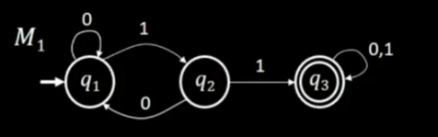

b) What is the regular expression of the above given FA?

c) Where do we end on reading 101 in the given FA?

d) What are the five components of Finite Automata?

e) What is regular language? Give your answer based on Instructor definition.